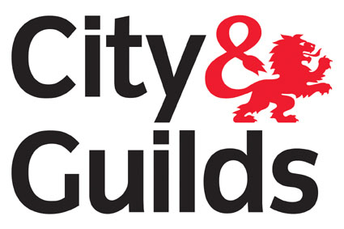
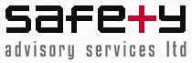
NVQ Level 3 Certificate in Occupational Health and Safety (QCF)
Qualification No: 3654-03 Accreditation No: 600/1070/8
Who is this qualification for?

These qualifications are ideal for those responsible for health and safety in the workplace, or for those whose role is to develop and implement health and safety policy and procedures.
For candidates who wish to develop their skills and knowledge in the application of Occupational health and safety good practice in the workplace
Qualification Structure

To achieve the Level 3 NVQ Certificate in Occupational Health and Safety, learners must achieve a total of 31 credits. Learners will need to obtain a total of 23 credits from the mandatory units (301 – 305) and a minimum of 8 credits from the optional units (306 – 309).

Unit No | Unit Title | Credit Value
Mandatory
301 | Ensure responsibility for actions to reduce risks to health and safety | 4
302 | Develop procedures to safely control work operations | 4
303 | Monitor procedures to safely control work operations | 5
304 | Promote a culture of health and safety in the workplace | 4
305 | Conduct a health and safety risk assessment of the workplace | 6
Optional
306 | Investigate and evaluate health and safety incidents and complaints in the workplace | 5
307 | Make sure actions in the workplace aim to protect the environment | 4
308 | Review health and safety procedures in the workplace | 4
309 | Supervise the health, safety and welfare of a learner in the workplace | 4

What does this qualification cover?

It allows the candidates to learn, develop and practice the skills required for employment and/or career progression in the health and safety sector.
The candidate will be required to complete a portfolio of evidence covering the assessment criteria for all units within their registration period, qualification usually takes between
6 – 10 months.

Entry requirements?

There are no entry requirements for this qualification as long as the candidate displays the potential to be able to achieve the qualification.
Candidates must be over the age of 19.

Progression routes?

A Certificate in Occupational Health can help you develop your career as a health and safety practitioner in almost any industry.
Learners can also choose to go on to take the following qualification:
- Level 5 NVQ Diploma in Occupational Health and Safety Practice (QCF)
- Level 5 NVQ in Management of Health and Safety.
Level 5 NVQ in Managing Health and Safety.

Safety Advisory Services Ltd is an Approved City and Guilds Provider, Centre No: 722250.

Find us at: 1 Cranham Court, Arden Square, Crewe Business Park, Crewe, CW1 6HA (UK).

Call on: +44 (0)1270 584552
Email us: services@sas-ltd.co.uk
Web: www.sas-ltd.co.uk

Ref: /tmp/in/input.doc

